Supplementary Material 1. Training data and model code
Supplementary Material 1 provides the training data and model code used for model training, feature analysis, and regional forest-type prediction in this study. The training data file, training data.csv, contains 123,626 samples and 70 fields, including sample identifiers, geographic coordinates, land-cover class information, and 64-dimensional AlphaEarth Foundation (AEF) embedding features. Specifically, id and point_id are sample identifiers, lon and lat represent geographic coordinates, lc_code and type indicate the original land-cover class information, and A00–A63 represent the extracted AEF embedding dimensions.
The model code consists of three parts. The first script is used for model training and accuracy comparison under different classification strategies. The second script is used for feature importance ranking and feature subset sensitivity analysis under the ET + KNN model combination. The third script is used for regional forest-type prediction based on selected AEF features and the optimal ET + KNN model combination. These files support the classification strategy comparison, feature contribution analysis, and regional forest-type mapping results presented in this study.
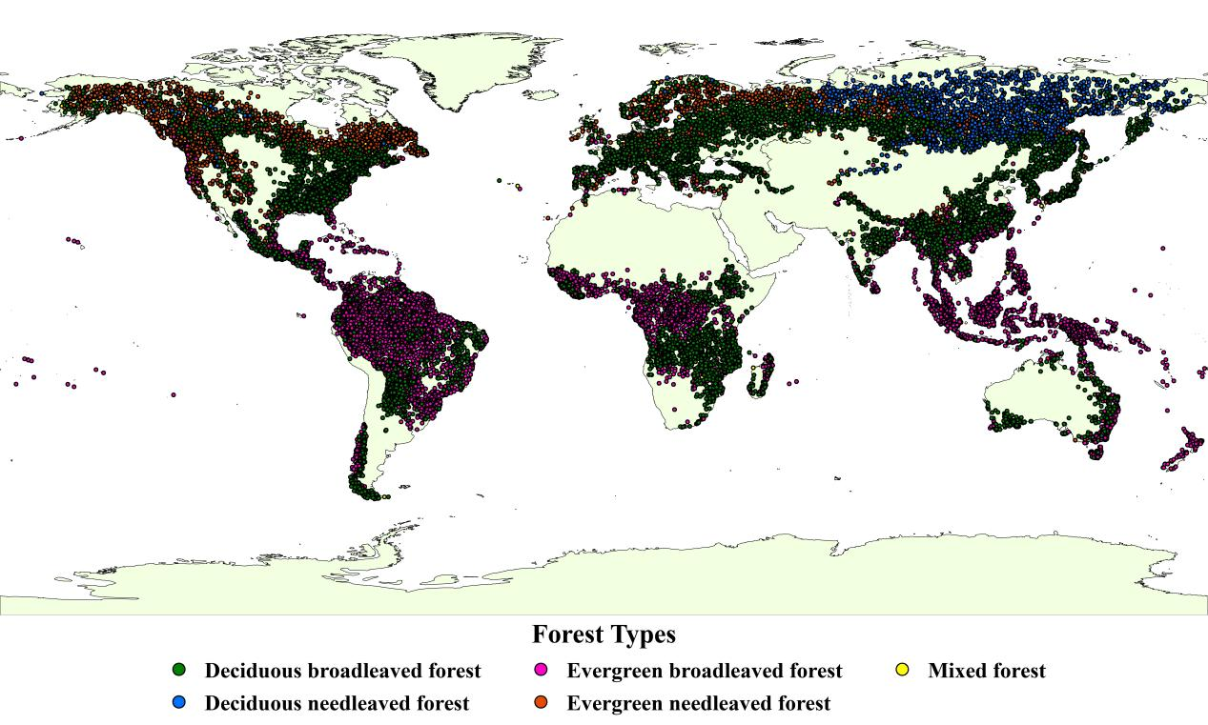
Fig. 1 Spatial distribution of global sample points used for forest type classification model training

